Cheat sheet – Connection PADDLE 2.0

Connections BBB:
P8_36 | ePWMSS1A | PWM Motor 1
P8_45 | ePWMSS2A | PWM Motor 2
P9_12 | GPIO_60 | Enable ESCON 1
P8_18 | GPIO_65 | Enable ESCON 2
P9_42B(92) | eQEP0A | Encoder 1 – Chan A
P9_27 | eQEP0B | Encoder 1 – Chan B
P8_12 | eQEP2A | Encoder 2 – Chan A
P8_11 | eQEP2B | Encoder 2 – Chan B
P9_17 | SPI_CS | Slave selection
P9_18 | SPI_MOSI | Master Out Slave In
P8_21 | SPI_MISO | Master In Slave Out
P8_22 | SPI_SCLK | SPI Clock Signal
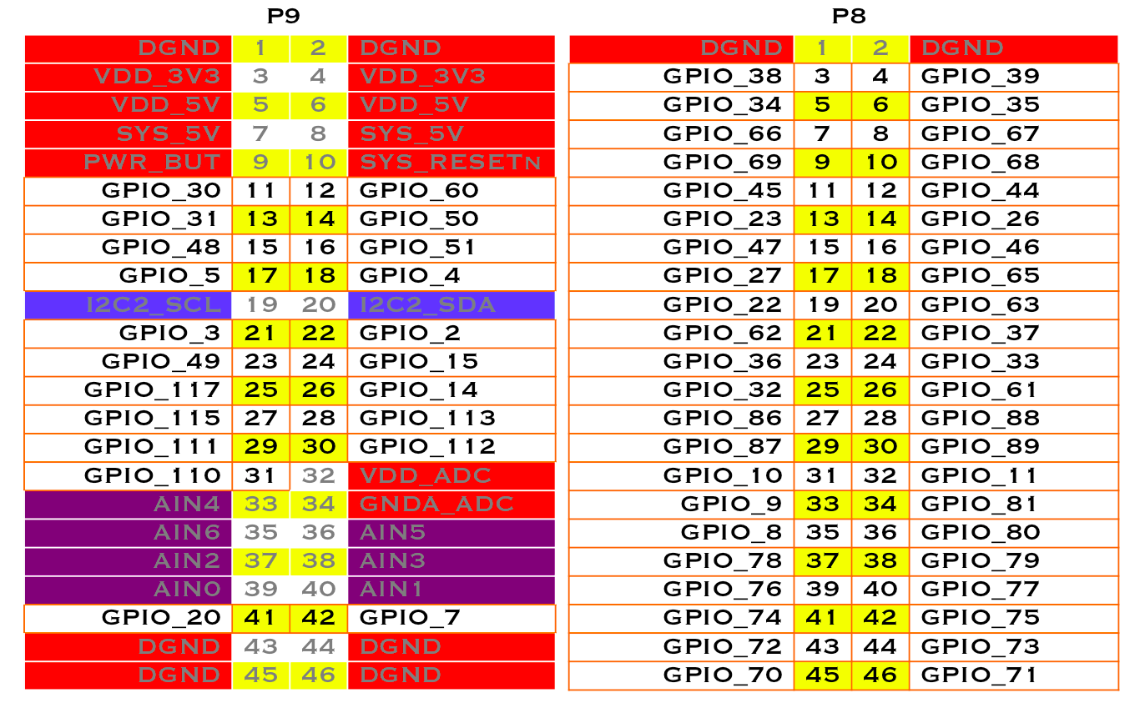

Connections ESCON:
J1: Power | 1 | Alim -
J1: Power | 2 | Alim +
J2: Motor | 1 | Motor +
J2: Motor | 2 | Motor -
J3:Hall Sensor | 4 | +5VDD Alim carte ADC
J3:Hall Sensor | 5 | GND Alim carte ADC
J4: Encoder  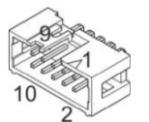 | 2 | + 5VDC (Encoder supply) – NOT CONNECTED
 | 3 | GND
 | 6 | Channel A
 | 8 | Channel B
J5: Digital | 1 | PWM
J5: Digital | 2 | Enable
J5: Digital | 5 | GND

ESCON to BBB encoder cable:
(right to left while facing the connector)
2 | Red | + 5VDC (Encoder supply) – NOT CONNECTED
3 | Orange | GND
6 | Blue | Channel A
8 | Green | Channel B

Encoder to BBB shielded cable:
Color | Stripe | Function
Red | Black | +5V – encoder power supply
Black | Red | GND
White | Black | Channel A
Green | Black | Channel B

SPI Protocol BBB ← → ADC
24 bits (8 write + 16 read)
Write in MOSI:
AIN1 : 0x9E
AIN2 : 0xDE
AIN3 : 0xAE
AIN4 : 0xEE
Read : 0x00
Read in MISO: First 9 bits are 0, next 12 are the data, last 3 are always 0.

Force sensors to hx711 (not used anymore):
E+ | Red
E- | Black
S- | White
S+ | Green

hx711 to BBB (not used anymore):
hx711 | BBB
GND | Not connected (only one needed)
VCC | Not connected (only one needed)
DOUT | Force Sensor 1 SIG (IN) (cf table 1)
Cable soldered on PIN 15 | +3.3 V
GND | GND
VCC | +3.3 V
SCK | Force Sensor 1 SCK (OUT) (cf table 1)

